See also Survey report: https://docs.google.com/document/d/1HTKA3D7_zN7_LtK2QdoRdt9HFbU-cUtC41RQzNbYDlk/edit#heading=h.cdhv3bjmwbcp

ISDC 2021  
*System dynamics conference 2021*  
**August 25th 2021, 9:34 am CEST**

**We would like to know more about your impressions of the 2021 International Conference of the System Dynamics Society, held in virtual Chicago. For each of the following statements, please indicate your answer by selecting one of the options available. Most questions can be answered on a scale from 1 = very negative, 2 = negative; 3 = somewhat negative; 4 = neutral, 5 = somewhat positive; 6 = positive and 7 = very positive. If a question refers to an activity you did not participate in, or you have no opinion on the topic raised, please leave it blank.**

**Q1 - What aspects of the virtual conference did you experience? Select all that apply.**

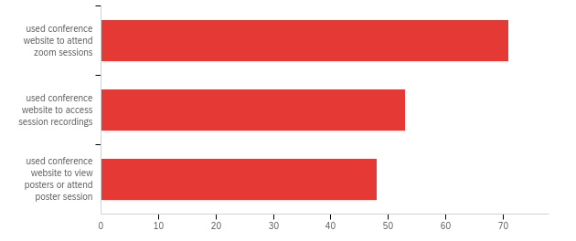

|  |  |  |  |
| --- | --- | --- | --- |
| # | Answer | % | Count |
| 1 | used conference website to attend zoom sessions | 41.28% | 71 |
| 4 | used conference website to access session recordings | 30.81% | 53 |
| 5 | used conference website to view posters or attend poster session | 27.91% | 48 |
|  | Total | 100% | 172 |

**Q2 - When it comes to the content of the conference program, my evaluation is:**

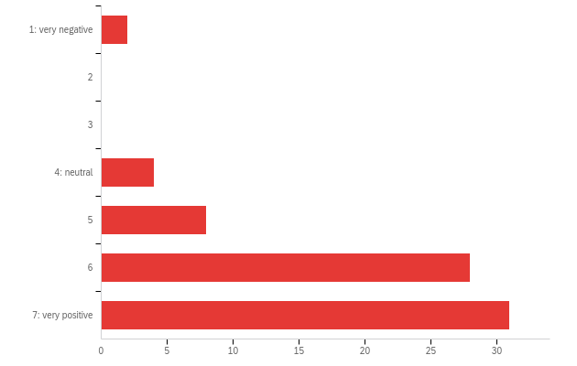

|  |  |  |  |  |  |  |  |
| --- | --- | --- | --- | --- | --- | --- | --- |
| # | Field | Minimum | Maximum | Mean | Std Deviation | Variance | Count |
| 1 | When it comes to the content of the conference program, my evaluation is: | 1.00 | 7.00 | 6.07 | 1.20 | 1.43 | 73 |

|  |  |  |  |
| --- | --- | --- | --- |
| # | Answer | % | Count |
| 1 | 1: very negative | 2.74% | 2 |
| 2 | 2 | 0.00% | 0 |
| 3 | 3 | 0.00% | 0 |
| 4 | 4: neutral | 5.48% | 4 |
| 5 | 5 | 10.96% | 8 |
| 6 | 6 | 38.36% | 28 |
| 7 | 7: very positive | 42.47% | 31 |
|  | Total | 100% | 73 |

**Q2b - Additional comments**

|  |
| --- |
| Additional comments |
| Didn't think the plenary talks were that innovative or newly educational. |
| As someone whose work is focused on qualitative modelling and equity/diversity, I found less content than perhaps I would have like. I'm looking forward to the next conference with a Diversity theme :) |
| My father passed away during that week, and I could not attend to many presentations. |
| Glad there were recordings because I had a number of conflicts in sessions I wanted to be at. |
| I got a lot out of the conference. This is my third conference, and this time I have really engaged with it. I am still going through notes and watching recordings and downloading citations of key papers. Really very helpful. |
| There was almost too much program. |
| The program content included works in progress, new research, and experts from other fields that could be leveraged, integrated, or supports by system dynamics modeling. A huge spectrum of research and application domains was represented. |
| Well designed and organized content for all the sessions I joined. There were several excellent and lucid speakers, not only in plenaries but also in parallel; AND not only the established pros but also rookie doctoral students. I provided some feedback about good talks in the link for 'best speakers'. In addition I'd like to add the speakers and session chair for Plenary 5 which I viewed as a recorded session. Peter Hovmand's and Damon Centola's talks were excellent, and Camilo Olaya was an effective chair. |
| My rating is based on the generally high quality of the plenaries. Parallel sessions were highly variable in quality and on average too low. organization of everything was outstanding. |
| The remote session has improved tremendously! I commend the organizers! |
| Ibreally likrd thst it was so full with marvelous content. |
| I found the feedback sessions and the PAW very useful. |
| Having only abstracts to select which presentation to attend I only select 3. I did not find one presentation about a model having been implemented.. |
| I'm a first time attendee, and much of the content was over my head but it broadened my horizon on the possibilities of SD. |
| Each of the talks from the people from Argonne were interesting and presented quite well, but perhaps we could have had fewer of them. They had quite a number of similarities one to the other. |
| I thought the plenary contributions were particularly well presented and relevant. |
| The content was fine/good even, but I did not like the format of only using Zoom and not having a networking platform like last years 3D virtual world. |
| I think the plenaries were too national lab focused. |

**Q3 - When it comes to the conference website and access to presented work, my evaluation is:**

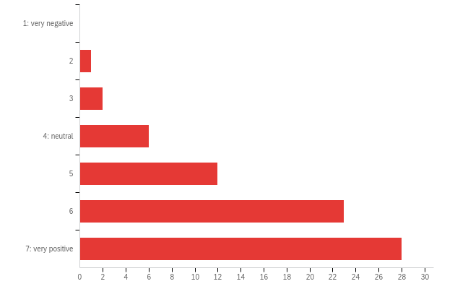

|  |  |  |  |  |  |  |  |
| --- | --- | --- | --- | --- | --- | --- | --- |
| # | Field | Minimum | Maximum | Mean | Std Deviation | Variance | Count |
| 1 | When it comes to the conference website and access to presented work, my evaluation is: | 2.00 | 7.00 | 5.92 | 1.16 | 1.35 | 72 |

|  |  |  |  |
| --- | --- | --- | --- |
| # | Answer | % | Count |
| 1 | 1: very negative | 0.00% | 0 |
| 2 | 2 | 1.39% | 1 |
| 3 | 3 | 2.78% | 2 |
| 4 | 4: neutral | 8.33% | 6 |
| 5 | 5 | 16.67% | 12 |
| 6 | 6 | 31.94% | 23 |
| 7 | 7: very positive | 38.89% | 28 |
|  | Total | 100% | 72 |

**Q3b - Additional comments**

|  |
| --- |
| Additional comments |
| I found the layout of the detailed schedule a bit tricky. Screen kept scrolling back to the top. The pdf version probably better but then hard to mark things as favourites. |
| The event schedule, at some 50 pages, was impossible to scan or use in an organized manner, since there was no table of contents with links, or a left panel with links like in a PDF document. I had to print the page to a pdf file to be able to mark it up and decide what to attend. |
| I would've liked to be able to search the whole schedule for a name of a title - I had to try and remember which Session they were in, when I wanted to find them again. |
| The schedule going to the present is good thing to have. I did not used the "my schedule" page very much. |
| I thought access to zoom through the schedule links went very smoothly indeed. |
| The external conference website sometimes portrays contents in unformatted ways, but what we used during the conference was great. |
| The conference website ran smoothly except for a few glitches with connectivity on Monday. There were several website features I found particularly useful: adjustment to local time zone; auto-scroll to current position in the conference schedule; easy access to participant profiles and to abstracts for papers. There's one feature of online Zoom sessions I find distracting and annoying - chat boxes that keep appearing during speaker presentations (when a minority of participants keep messaging everyone in the session). |
| Great job! |
| It is hard to locate conference website and access to presented work |
| The website too has improved greatly |
| That it kept taking me to the right day.and the recordings were in the same place as the original access |
| Hard to find items/names of presenters etc on the schedule webpage, searching was problematic. |
| I was able to download many but not all the papers and access many of the videos |
| The site was difficult to navigate at times |
| There was some trial and error but under the circumstances people were well prepared. |
| When it wasn't overloaded, the site worked well. Would have appreciated an easier way to see an overview of the schedule, instead of just a long list. I saw the basic overview, but I found it too basic. |
| Conference website could be made more interactive, lean and less bulky |
| It worked really well. There were mpstly just confusions around links and sometimes the schedule not advancing to now. |

**Q4 - When it comes to the services provided by the conference organization, including technical support, my evaluation is:**

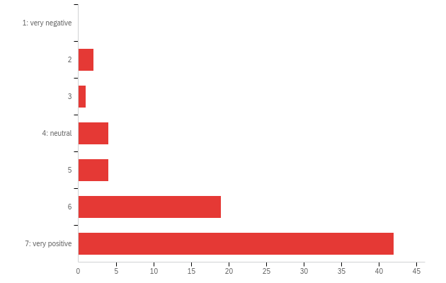

|  |  |  |  |  |  |  |  |
| --- | --- | --- | --- | --- | --- | --- | --- |
| # | Field | Minimum | Maximum | Mean | Std Deviation | Variance | Count |
| 1 | When it comes to the services provided by the conference organization, including technical support, my evaluation is: | 2.00 | 7.00 | 6.26 | 1.17 | 1.36 | 72 |

|  |  |  |  |
| --- | --- | --- | --- |
| # | Answer | % | Count |
| 1 | 1: very negative | 0.00% | 0 |
| 2 | 2 | 2.78% | 2 |
| 3 | 3 | 1.39% | 1 |
| 4 | 4: neutral | 5.56% | 4 |
| 5 | 5 | 5.56% | 4 |
| 6 | 6 | 26.39% | 19 |
| 7 | 7: very positive | 58.33% | 42 |
|  | Total | 100% | 72 |

**Q4b - Additional comments**

|  |
| --- |
| Additional comments |
| Alan Mozaffari saved the day on chairing my session. Due to a thunderstorm,, I lost all power. Use battery power backup, I was able to email home on how to run the session, which he did well. |
| The organization as a whole was wonderful, the technical support people were helpful and very supportive. |
| Support personnel was very much commited to the success of the event. |
| Very friendly and helpful tech support for my parallel presentation and for other presentations I attended. |
| Technical support for Zoom sessions was very good and the conference team were quick to respond to any questions I raised. They were also patient! |
| as a first time session chair I had great technical support |
| Terrific. Thank you all |
| Technical support was not present in our session |
| Conference staff assume a bit more Zoom proficiency than is justified simply because, they, themselves take such proficiency for granted. |
| Every time i had a question there was someone not far away |
| Highly responsive (volunteer) elves at the ISDC! |
| I found the technical support very friendly |
| Everyone in the best mood. Always great to interact with the SD community! |
| Some time zone confusions. I know what that's like. |
| kind of N/A here |
| Unfortunately technical chair for my session, which i was chairing, couldn't make it to the session |
| The technical support, including by chat and in the Loop, was excellent. |

**Q5 - When it comes to the opportunity to socialize at the conference, my evaluation is:**

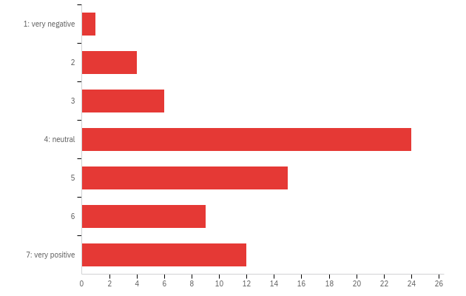

|  |  |  |  |  |  |  |  |
| --- | --- | --- | --- | --- | --- | --- | --- |
| # | Field | Minimum | Maximum | Mean | Std Deviation | Variance | Count |
| 1 | When it comes to the opportunity to socialize at the conference, my evaluation is: | 1.00 | 7.00 | 4.73 | 1.46 | 2.14 | 71 |

|  |  |  |  |
| --- | --- | --- | --- |
| # | Answer | % | Count |
| 1 | 1: very negative | 1.41% | 1 |
| 2 | 2 | 5.63% | 4 |
| 3 | 3 | 8.45% | 6 |
| 4 | 4: neutral | 33.80% | 24 |
| 5 | 5 | 21.13% | 15 |
| 6 | 6 | 12.68% | 9 |
| 7 | 7: very positive | 16.90% | 12 |
|  | Total | 100% | 71 |

**Q5b - Additional comments**

|  |
| --- |
| Additional comments |
| the dialog-sessions gave everyone an opportunity to say something |
| I appreciate the (laughter) yoga sessions |
| I didn't really socialise so hard to say. |
| I didn't use the breakouts because I didn't know how to "hang out" and bump into people and chat, as at a physical conference. As a result, this conference has zero networking benefits for me. |
| There were a lot of innovative opportunities to socialise. |
| Nothing beats in person... but it was as good as it could be for virtual |
| I did not use it very much. As I said, my father passed away and socialized less than what I would have wantef. |
| Didn't really try. |
| I didn’t really use this |
| I didn't take up all the social opportunities but enjoyed those I engaged with. |
| The conference offered many opportunities to network and socialize outside of presentation sessions. |
| I didn't join any of the social sessions so I don't have an opinion on this topic - except to say that the range of social activities looked broad and creative. |
| the opportunities were there, I just find it too awkward to engage socially virtually |
| Harder on zoom of course but still possible |
| It is difficult to socialize at virtual conference |
| Not sure i really figured this part out |
| The opportunities were there but maybe ppl were too busy/schedule too hectic, sick of Zooms?? Not sure. |
| I used the private rooms in the Loop and they were very worthwhlie. |
| I found the dialogue sessions were great. I did not use the chat |
| Yeah, I have not socialised too much. Well, took part on one yoga session only. I was not in the best mood though. |
| I don't find the online format conducive to that, although invitations to contact people afterwards were appreciated. |
| Last year in Bergen, the 3D world really was a benefit from a socializing point of view. I didn't feel as much connection to people at all this year and the zoom rooms didn't seem to work much - was quite awkward. |
| Needs to be improved. We need a virtual place where everyone comes together at the same time. We need to bump more often |
| I think the opportunities to meet up with people, especially people you may not know (but there were many people I do know who I never "saw"), were very limited. |

**Q6 - When it comes to overall value, my evaluation is:**

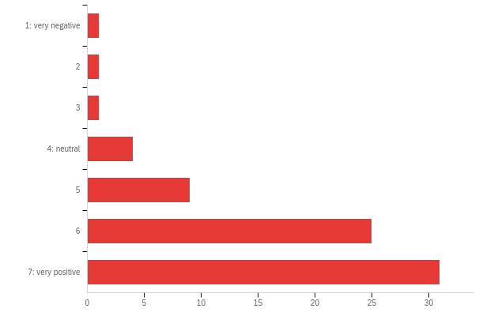

|  |  |  |  |  |  |  |  |
| --- | --- | --- | --- | --- | --- | --- | --- |
| # | Field | Minimum | Maximum | Mean | Std Deviation | Variance | Count |
| 1 | When it comes to overall value, my evaluation is: | 1.00 | 7.00 | 6.03 | 1.21 | 1.47 | 72 |

|  |  |  |  |
| --- | --- | --- | --- |
| # | Answer | % | Count |
| 1 | 1: very negative | 1.39% | 1 |
| 2 | 2 | 1.39% | 1 |
| 3 | 3 | 1.39% | 1 |
| 4 | 4: neutral | 5.56% | 4 |
| 5 | 5 | 12.50% | 9 |
| 6 | 6 | 34.72% | 25 |
| 7 | 7: very positive | 43.06% | 31 |
|  | Total | 100% | 72 |

**Q6b - Additional comments**

|  |
| --- |
| Additional comments |
| There seems to be some sort of hidden forum for the in group who does all the fabulous work for the SD society, such as conference planning. I sure would help to make this discussion transparent. There is a huge amount of discussion going on somewhere. |
| It was great... and I think we should keep virtual in future, even if back to in person |
| The value of the conference resides on having a glimpse of the current state of affairs. |
| Virtual is mist preferred |
| I submitted quite a few papers along with colleagues and I think the peer reviewer process was somewhat harsh at times and not constructive |
| I reveived a conference scholarship, but would havr been unable to attend otherwise |
| I hope that 'getting back to normal' doesn't mean the SDS dispenses with the online aspect. |

**Q7 - When it comes to the plenary sessions, my evaluation is:**

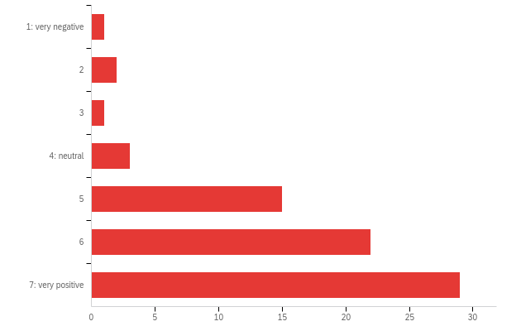

|  |  |  |  |  |  |  |  |
| --- | --- | --- | --- | --- | --- | --- | --- |
| # | Field | Minimum | Maximum | Mean | Std Deviation | Variance | Count |
| 1 | When it comes to the plenary sessions, my evaluation is: | 1.00 | 7.00 | 5.89 | 1.29 | 1.66 | 73 |

|  |  |  |  |
| --- | --- | --- | --- |
| # | Answer | % | Count |
| 1 | 1: very negative | 1.37% | 1 |
| 2 | 2 | 2.74% | 2 |
| 3 | 3 | 1.37% | 1 |
| 4 | 4: neutral | 4.11% | 3 |
| 5 | 5 | 20.55% | 15 |
| 6 | 6 | 30.14% | 22 |
| 7 | 7: very positive | 39.73% | 29 |
|  | Total | 100% | 73 |

**Q8 - When it comes to the parallel sessions, my evaluation is:**

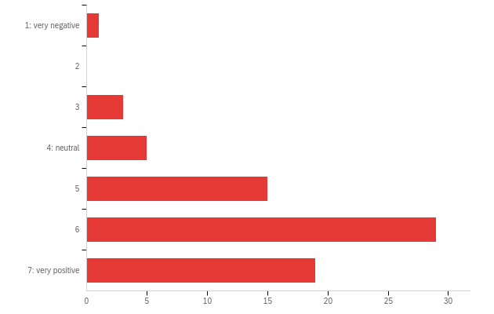

|  |  |  |  |  |  |  |  |
| --- | --- | --- | --- | --- | --- | --- | --- |
| # | Field | Minimum | Maximum | Mean | Std Deviation | Variance | Count |
| 1 | When it comes to the parallel sessions, my evaluation is: | 1.00 | 7.00 | 5.72 | 1.18 | 1.40 | 72 |

|  |  |  |  |
| --- | --- | --- | --- |
| # | Answer | % | Count |
| 1 | 1: very negative | 1.39% | 1 |
| 2 | 2 | 0.00% | 0 |
| 3 | 3 | 4.17% | 3 |
| 4 | 4: neutral | 6.94% | 5 |
| 5 | 5 | 20.83% | 15 |
| 6 | 6 | 40.28% | 29 |
| 7 | 7: very positive | 26.39% | 19 |
|  | Total | 100% | 72 |

**Q9 - When it comes to the work-in-progress (WIP) sessions, my evaluation is:**

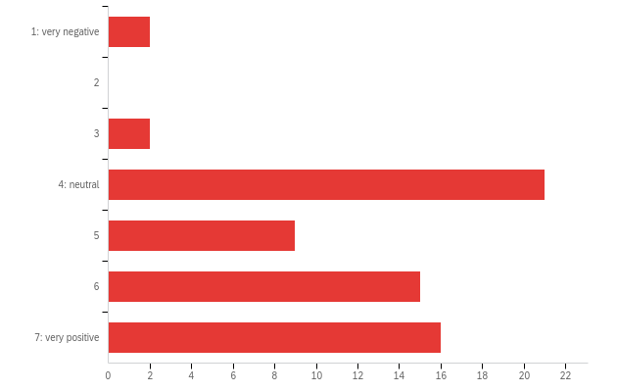

|  |  |  |  |  |  |  |  |
| --- | --- | --- | --- | --- | --- | --- | --- |
| # | Field | Minimum | Maximum | Mean | Std Deviation | Variance | Count |
| 1 | When it comes to the work-in-progress (WIP) sessions, my evaluation is: | 1.00 | 7.00 | 5.22 | 1.45 | 2.11 | 65 |

|  |  |  |  |
| --- | --- | --- | --- |
| # | Answer | % | Count |
| 1 | 1: very negative | 3.08% | 2 |
| 2 | 2 | 0.00% | 0 |
| 3 | 3 | 3.08% | 2 |
| 4 | 4: neutral | 32.31% | 21 |
| 5 | 5 | 13.85% | 9 |
| 6 | 6 | 23.08% | 15 |
| 7 | 7: very positive | 24.62% | 16 |
|  | Total | 100% | 65 |

**Q10 - When it comes to the dialog sessions, my evaluation is:**

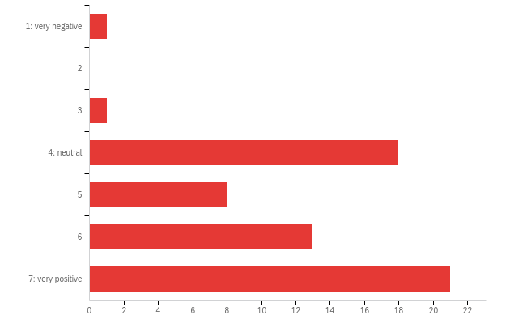

|  |  |  |  |  |  |  |  |
| --- | --- | --- | --- | --- | --- | --- | --- |
| # | Field | Minimum | Maximum | Mean | Std Deviation | Variance | Count |
| 1 | When it comes to the dialog sessions, my evaluation is: | 1.00 | 7.00 | 5.50 | 1.39 | 1.93 | 62 |

|  |  |  |  |
| --- | --- | --- | --- |
| # | Answer | % | Count |
| 1 | 1: very negative | 1.61% | 1 |
| 2 | 2 | 0.00% | 0 |
| 3 | 3 | 1.61% | 1 |
| 4 | 4: neutral | 29.03% | 18 |
| 5 | 5 | 12.90% | 8 |
| 6 | 6 | 20.97% | 13 |
| 7 | 7: very positive | 33.87% | 21 |
|  | Total | 100% | 62 |

**Q11 - When it comes to the feedback sessions, my evaluation is:**

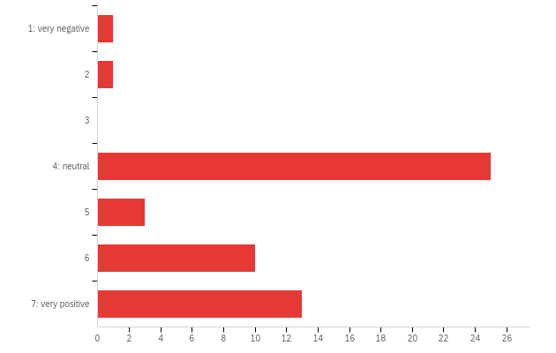

|  |  |  |  |  |  |  |  |
| --- | --- | --- | --- | --- | --- | --- | --- |
| # | Field | Minimum | Maximum | Mean | Std Deviation | Variance | Count |
| 1 | When it comes to the feedback sessions, my evaluation is: | 1.00 | 7.00 | 5.08 | 1.45 | 2.11 | 53 |

|  |  |  |  |
| --- | --- | --- | --- |
| # | Answer | % | Count |
| 1 | 1: very negative | 1.89% | 1 |
| 2 | 2 | 1.89% | 1 |
| 3 | 3 | 0.00% | 0 |
| 4 | 4: neutral | 47.17% | 25 |
| 5 | 5 | 5.66% | 3 |
| 6 | 6 | 18.87% | 10 |
| 7 | 7: very positive | 24.53% | 13 |
|  | Total | 100% | 53 |

**Q12 - When it comes to the Student-organized Colloquium on Sunday, my evaluation is:**

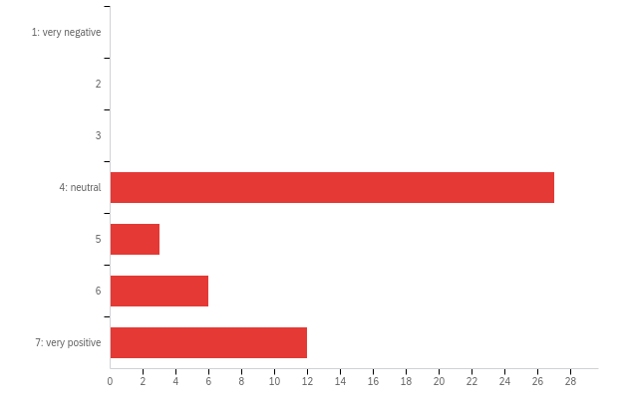

|  |  |  |  |  |  |  |  |
| --- | --- | --- | --- | --- | --- | --- | --- |
| # | Field | Minimum | Maximum | Mean | Std Deviation | Variance | Count |
| 1 | When it comes to the Student-organized Colloquium on Sunday, my evaluation is: | 4.00 | 7.00 | 5.06 | 1.30 | 1.68 | 48 |

|  |  |  |  |
| --- | --- | --- | --- |
| # | Answer | % | Count |
| 1 | 1: very negative | 0.00% | 0 |
| 2 | 2 | 0.00% | 0 |
| 3 | 3 | 0.00% | 0 |
| 4 | 4: neutral | 56.25% | 27 |
| 5 | 5 | 6.25% | 3 |
| 6 | 6 | 12.50% | 6 |
| 7 | 7: very positive | 25.00% | 12 |
|  | Total | 100% | 48 |

**Q13 - When it comes to the poster sessions on Tuesday, my evaluation is:**

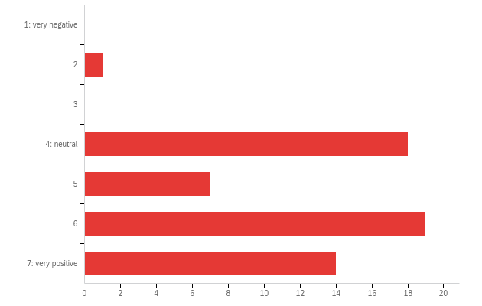

|  |  |  |  |  |  |  |  |
| --- | --- | --- | --- | --- | --- | --- | --- |
| # | Field | Minimum | Maximum | Mean | Std Deviation | Variance | Count |
| 1 | When it comes to the poster sessions on Tuesday, my evaluation is: | 2.00 | 7.00 | 5.44 | 1.24 | 1.53 | 59 |

|  |  |  |  |
| --- | --- | --- | --- |
| # | Answer | % | Count |
| 1 | 1: very negative | 0.00% | 0 |
| 2 | 2 | 1.69% | 1 |
| 3 | 3 | 0.00% | 0 |
| 4 | 4: neutral | 30.51% | 18 |
| 5 | 5 | 11.86% | 7 |
| 6 | 6 | 32.20% | 19 |
| 7 | 7: very positive | 23.73% | 14 |
|  | Total | 100% | 59 |

**Q14 - When it comes to the workshops on Thursday and Friday, my evaluation is:**

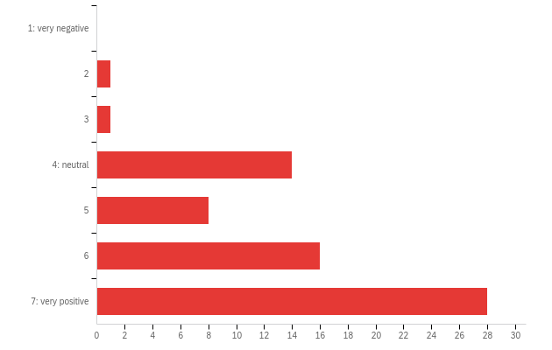

|  |  |  |  |  |  |  |  |
| --- | --- | --- | --- | --- | --- | --- | --- |
| # | Field | Minimum | Maximum | Mean | Std Deviation | Variance | Count |
| 1 | When it comes to the workshops on Thursday and Friday, my evaluation is: | 2.00 | 7.00 | 5.78 | 1.29 | 1.67 | 68 |

|  |  |  |  |
| --- | --- | --- | --- |
| # | Answer | % | Count |
| 1 | 1: very negative | 0.00% | 0 |
| 2 | 2 | 1.47% | 1 |
| 3 | 3 | 1.47% | 1 |
| 4 | 4: neutral | 20.59% | 14 |
| 5 | 5 | 11.76% | 8 |
| 6 | 6 | 23.53% | 16 |
| 7 | 7: very positive | 41.18% | 28 |
|  | Total | 100% | 68 |

**Q14b - If you have any comments on session formats, please list them here.**

|  |
| --- |
| If you have any comments on session formats, please list them here. |
| Plenary sessions were mixed quality with some amazing and interesting ones, and others not so much. |
| I appreciate a better alignment with conference threats and SIG scope as well as the involvement of SIG during the conference. |
| I wonder if the distinction between plenary and parallel gets a bit lost on-line. But you are operating under enormous constraints so I have nothing but praise for the organisers. |
| It was hard to see the whole and to look at the posters without downloading them. |
| For me the Publication Assistance Workshop was a huge benefit. Please commend Shayne on a great job. |
| Great to have a variety of session formats: something for everyone :) |
| Didn't attend any WIP, feedback, or dialog sessions or Th/F workshops |
| I didn’t attend anything other than plenaries, parallels and posters, so I rated everything else “neutral. “ It might have helped the survey to have a “did no attend” or “not applicable” choice. |
| Not all presentations and workshops had slides available, it's so helpful when they are, because there's less of a need to try to keep up listening and taking notes at the same time. |
| As with other conferences, this society is exploring and expanding ways to meet in the virtual world. I think the system dynamics society has succeeded in expanding opportunities, but there are still practical limitations when accommodating a large number of participants across many time zones. |
| I found the dialogue sessions to offer an effective and engaging experience. I attended two such sessions. The success of dialogue sessions depends quite a lot on the facilitation skills of the Chairs. The Chair of the first session I attended was very effective at drawing-in participants and adapting the session framework to the flow of conversation. The Chair of the second session used a more rigid framework to shape the dialogue. This rigidity led to a somewhat 'slow-burn' of conversation. despite the interesting topic and promising mix of participants. Eventually however the session came to life with a lively exchange of views. Overall I felt the Dialogue sessions provided a good online substitute for informal chats with colleagues on topics of shared interest that often happen in face-to-face conferences. |
| did not attend student session |
| Due to the time difference, it is diffcult to attend most of the conference. |
| Perhaps split workshops between days so greater chance to attend more than just 1 or 2. (e.g., substitute for parallel sessions other days and add some parallels on the "workshop" day Thursday) |
| I like the format. There are many options to choose from which is always good. And the fact that there are videos available if you couldn't attend live is great. |
| much less sessions of longer durations and better quality |
| Some of the workshops and dialogue sessions could have provided more information befotehand; I really enjoyed the format of the poster sessions |
| One workshop attended was good and the other not so useful. Same with the plenaries. I did appreciate the dedicated networking sessions where people where randomly paired together in Zoom. That isn't listed here, but I did like those! Just wish there was much more of it. |
| Posters too short |
| There was less time to see posters in Zoom than there was last year in the 3D world or in person. When you moved, you always came into the middle of a presentation, so often had to wait just to see all of the poster and what it was about. The 3D world worked much more like the real world where you could individually review the poster while listening to what was going on and then join in if you wanted, or move on to the next. |

**Q15 - How do you rate the overall quality of the presented work?**

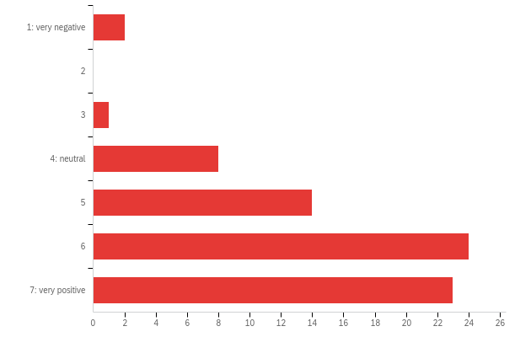

|  |  |  |  |  |  |  |  |
| --- | --- | --- | --- | --- | --- | --- | --- |
| # | Field | Minimum | Maximum | Mean | Std Deviation | Variance | Count |
| 1 | How do you rate the overall quality of the presented work? | 1.00 | 7.00 | 5.72 | 1.30 | 1.70 | 72 |

|  |  |  |  |
| --- | --- | --- | --- |
| # | Answer | % | Count |
| 1 | 1: very negative | 2.78% | 2 |
| 2 | 2 | 0.00% | 0 |
| 3 | 3 | 1.39% | 1 |
| 4 | 4: neutral | 11.11% | 8 |
| 5 | 5 | 19.44% | 14 |
| 6 | 6 | 33.33% | 24 |
| 7 | 7: very positive | 31.94% | 23 |
|  | Total | 100% | 72 |

**Q15b - Additional comments**

|  |
| --- |
| Additional comments |
| I had a lot of conflicts, so only participated in few sessions. |
| Don't understand why SIG and Chapter meetings lagged behind the main event. This makes no sense to me. |
| My rating for "overall quality of the presented work" is relative to how it advances society's ability to solve important common good problems, rather than business problems. |
| My one comment is re the Diversity of the plenary sessions (and also the plenary chairs). While all the speakers/chairs that I saw did a good job, there was a lack of gender diversity and also race. The plenaries are the one aspect that can be totally controlled, so it would be good to see a greater diversity here. |
| Thanks. |
| In all the sessions I joined the speakers and chairs were well prepared and stuck to their scheduled time slots. The content was generally good and carefully prepared. Several of the sessions were really excellent. |
| Plenaries were generally excellent. Parallels highly variable and on average too low. Much parallel work should have been is wip or feedback or rejected. |
| Some are good but some are not good enough. |
| I enjoyed the two dialog sessions I attended very much - both turned into open discussions with great input. The feedback sessions were very beneficial to me. It would have been valueable if the authors had been present to respond to the feedback. |
| I would include recommendations for good Zoom tutorials in the conference preparation materials. Conference organizer and staff, because they are proficient, take profficiency for granted and may, unwillittingly, be a bit contemptuous of those Zoom skills do not match thei r own,. |
| Many very high calibre presentations. Great standards for inclusion. And Chairs were all knowledge and had prepared well. |
| I think the Society is on the right track but has a long way to go to improve the quality of the presentations and the work being done. |
| I might be tired, but I feel I had more inishgts last year. |
| I think the precorded contributions are an improvement on the F2F format at previous conferences. |

**Q16 - How many years of experience do you have with system dynamics?**

|  |
| --- |
| How many years of experience do you have with system dynamics? |
| 25 |
| 2 |
| 2 |
| 12 |
| 2 |
| 5 years |
| 30+ |
| 19 |
| 14 years. Self-studied on Sterman, read it twice, taught myself Vensim, engaged in the SD email list, which was active in the late 2000s to sometime in the mid 2010s. I wonder where that discussion moved to. My participation on that email list is what helped me publish a paper on the SDR on Change Resistance as the Crux. |
| 7 |
| 2 |
| Since 1994; 27 years... |
| Since 2000, 22 years. |
| 50+ |
| 26 years |
| 2 |
| 3 |
| N/A |
| 16 |
| 8 |
| over 7 |
| More than 40 years. |
| 3 |
| 4 |
| 30 |
| 2 |
| 0 |
| 18 |
| I was first exposed to System Dynamics about 10 years ago and have followed the field since - sadly with a rather low intensity. |
| 2 |
| 3 |
| 17yeas |
| Many many |
| 3 |
| 2 |
| 10 |
| 25 years |
| about 20 years |
| &gt;1 |
| 15 |
| 3 |
| Three |
| 3 |
| 25 |
| 21 |
| 15 |
| 2 |
| one year |
| 1 |
| 4 |
| 25 |
| 3 |
| Eleven |
| 14 |
| 3 |
| 13 |
| 28 |
| 43 |
| 1 |

**Q17 - Have you attended the SD conference before? (Select one)**

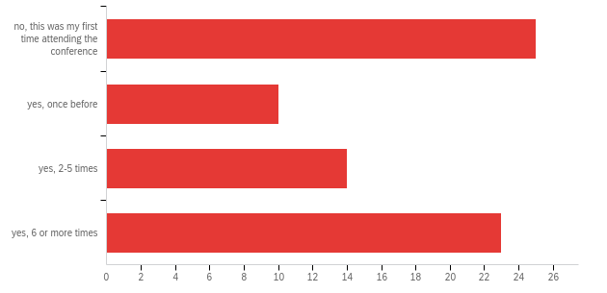

|  |  |  |  |  |  |  |  |
| --- | --- | --- | --- | --- | --- | --- | --- |
| # | Field | Minimum | Maximum | Mean | Std Deviation | Variance | Count |
| 1 | Have you attended the SD conference before? (Select one) | 1.00 | 6.00 | 3.79 | 2.13 | 4.55 | 72 |

|  |  |  |  |
| --- | --- | --- | --- |
| # | Answer | % | Count |
| 1 | no, this was my first time attending the conference | 34.72% | 25 |
| 4 | yes, once before | 13.89% | 10 |
| 5 | yes, 2-5 times | 19.44% | 14 |
| 6 | yes, 6 or more times | 31.94% | 23 |
|  | Total | 100% | 72 |

**Q18 - How do you evaluate this year’s virtual format as compared to the traditional face-to-face format?**

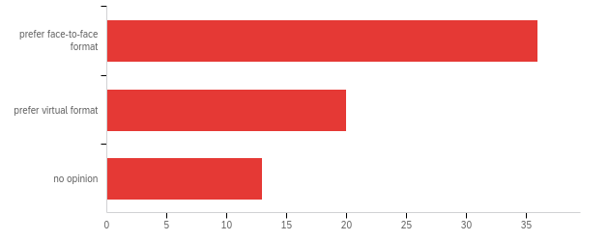

|  |  |  |  |  |  |  |  |
| --- | --- | --- | --- | --- | --- | --- | --- |
| # | Field | Minimum | Maximum | Mean | Std Deviation | Variance | Count |
| 1 | How do you evaluate this year’s virtual format as compared to the traditional face-to-face format? | 1.00 | 5.00 | 2.62 | 1.73 | 2.99 | 69 |

|  |  |  |  |
| --- | --- | --- | --- |
| # | Answer | % | Count |
| 1 | prefer face-to-face format | 52.17% | 36 |
| 4 | prefer virtual format | 28.99% | 20 |
| 5 | no opinion | 18.84% | 13 |
|  | Total | 100% | 69 |

**Q19 - Which of the following features, if any, would be worthwhile to continue for future conferences? Please check all that apply.**

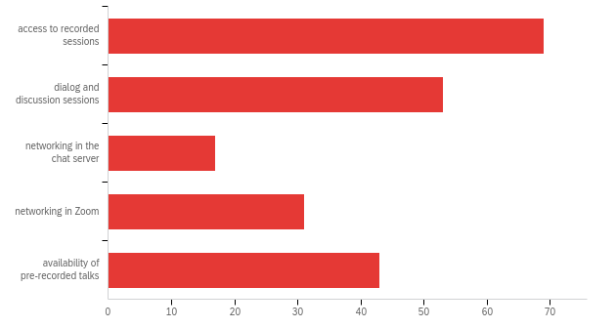

|  |  |  |  |
| --- | --- | --- | --- |
| # | Answer | % | Count |
| 1 | access to recorded sessions | 32.39% | 69 |
| 2 | dialog and discussion sessions | 24.88% | 53 |
| 3 | networking in the chat server | 7.98% | 17 |
| 6 | networking in Zoom | 14.55% | 31 |
| 7 | availability of pre-recorded talks | 20.19% | 43 |
|  | Total | 100% | 213 |

**Q19b - Other (please specify)**

|  |
| --- |
| Other (please specify) |
| Perhaps if it is in-person next year, for those who cannot travel to the conference, it would be interesting to be able to "attend" virtually by watching the live or recorded sessions, perhaps at a discounted price. |
| for future sessions please consider the (laughter) yoga |
| The above 5 check boxes don't make sense. They apply to a virtual conference. I assume the next one will be physical. |
| I would love to see an archive of noteworthy presentations kept as archive, with permissions of presenter(s). Hits on the recorded sessions could be tracked to log 'most popular' with meta-data about what topics the talks touched on. Comments in the chat log during zoom could also be kept available so the richness of the discussion could also be accessed, for those who want to see these comments. |
| I PREFER in person sessions, but I thought last year’s and this year’s virtual sessions were done well. |
| Last year, after online ISDC 2020 Bergen, I said I'd prefer a return to in-person conferences when the pandemic recedes, with some online capability maintained. Now I've been won over to the online format. I feel it's essential to retain this delivery mode even if and when in-person conferences resume. Virtual delivery and content enables flexible use of participants' time and is, of course more environmentally friendly. In the future I will increasingly value the option of 'flexible attendance'. |
| I do prefer a face-to-face format. However, for me the virtual format made it possible for me to attend. I consider myself a "reader"-personality and make use of recorded material rather rarely. Printable material - papers or presentations - would be useful to me. |
| The availability of pre-recorded talks is an excellent idea, and should be kept |
| I think the volunteer recognition award was a great idea. However, you might want to be more inclusive by reading all the names on the large plaque of all the volunteers in the Society. They all deserve some recognition. |
| having additionnal material instead of abstracts to be able to chose the presentation to attend. |
| I liked the Avatars in 2020. Oculus sessions with ARVR could also be quite cool. |
| Chat didn’t work this year |
| I wonder if it would be worth inviting participants to nominate papers of particular interest for further discussion. That might focus the conversation and get beyond Q&A. |
| The facilitated networking over zoom, where people are introduced to people they don't know at random. If some way to do this in person, great! And, I would have liked a 3D space to network and meet. |
| Some virtual component to allow people to attend who otherwise wouldn't be able to. |

**Q20 - What do you value most about participating in the conference?**

|  |
| --- |
| What do you value most about participating in the conference? |
| meeting good friends, learning about interesting research |
| Meeting new people, cross disciplinary learning in systems thinking, and learning new techniques in STELLA Architect |
| The wide range of topics and practitioners and experts that presented. |
| Hearing about all the exciting work members of the SD community are involved in, as well as receiving feedback on my work from some of the most prominent researchers in our field. |
| seeing how S can be used in so many different topics, from malaria spread to finance. |
| plenary sessions and contact to isee systems |
| simply that the conference happened at all |
| Feedback and discussion of current research, as reflected in presented papers. If this is good, it leads to important new contacts in one's research area. |
| Update on the field |
| Being immersed in the language and culture of Systems Dynamics practitioners - this was a great learning experience for me. |
| Building understanding about how to apply SD to pressing issues going on |
| I like the face-to-face social aspects of past conferences, but I think it's also good that more people can participate virtually who might not be able to come to a conference in person. Though challenging technically, I think hybrid conferences are the way to go in the future. |
| Seeing old friends and meeting new people. That’s why I prefer in person conferences. |
| Staying up to date with the latest research and networking. |
| Meeting the great figures in SD and learning the recent progresses in the literature |
| Invaluable for learning the latest developments in various aspects of SD, getting to know presenters, getting references for good sources, and for building confidence. |
| Catching up with friends, learning about new research in the field, networking |
| Socializing and valuable contacts. |
| Maintaining professional and academic relationships, learning about new and breakthrough research, learning about various application techniques and methods |
| The opportunity to hear about current SD work from both stars and students. |
| diversity and quality of the presentations |
| The workshops were great! |
| Have the oppotunity to learn about related work |
| The interaction with others - especially in the summer school sessions, the dialog sessions and the workshops |
| The modeling assistance and the opportunity to meet would be mentors |
| Reawakening personal relationships with professional colleagues of many years. |
| Connecting |
| Meeting people/seeing work that is along the same lines as your own. And learning new technical skills in workshops |
| Opportunity to present my work or that of my students and collaborators |
| The feedback sessions and the Publishing Assistance Workshop |
| presently there is little value participating at a conference, but 300 dollars and having not to travel is not expensive in monnez and time. Then i found one session interesting and worth the money and time spent this year; But i did not learn anything in the two past conferences that I attended. . |
| The dissemination of knowledge, meeting new people, and growth. |
| Workshops |
| Networking, workshops |
| The smart community. The topics. |
| Learning what others are doing in system dynamics. (That is when they're doing something interesting -- not necessarily new -- interesting. |
| It is rather insightful. I learn a lot! The participants are really kind! You manage to keep a great atmosphere. |
| dialog sessions |
| Content AND netwoorking |
| The quality of plenaries (and ESIR-B), the update on Jack Homer's work, and the workshops. |
| The friendly reception to new members, as I was this year. |
| Getting new ideas, catching up with friends, and networking. |
| presentations |
| Networking |
| Learning from peers, drawing inspiration and conviction from the work happening around the world |
| Experimental persons. |
| Learning |
| Networking and it was fairly limited this year. |
| The diversity and coverage |

**Q21 - What was the best thing that happened to you at the conference?**

|  |
| --- |
| What was the best thing that happened to you at the conference? |
| some new people I met and new research I have learned about |
| Each time I met a new organizer or attendee, there was just a brilliant, positive, warm group of people present (at least among the people I interacted with) |
| I enjoyed seeing people I know from the field and hearing about the work that really resonated with me and my interests. |
| Receiving an honorable mention for the Lupina Young award, when I was not expecting it at all. |
| John Sterman said my name , haha |
| workshops and immediate support |
| it wasn't that kind of event |
| Participating in the Publication Assistance Workshop. |
| Seeing the development of Stella software |
| The positive response I got from everyone I interacted with at the conference |
| Making new connections with people I didn't know |
| The opening presentations |
| The daily meditation sessions were a nice addition that I really enjoyed. I hope they continue to be offered. |
| The poster session rooms, as breakouts, were improved over those in 2020. |
| The PAW |
| Was introduced to many experienced modellers and learning materials that could be used as reference for my research |
| I think the best thing was that, unlike in live conference, it was possible to attend several sessions that took place at the same time, and to continue to take advantage of the opportunity to watch presentations after the event, via recordings. This means that, even though face to face is preferable for other reasons, the virtual format allowed me to see more presentations. I also felt a bit less nervous presenting at the conference, because it was virtual. |
| Being able to engage with a wider audience interested in SD and complexity |
| I got involved in a job negotiations |
| new interesting contacts |
| Getting feedback and support from experts that my work and research is worthwhile. |
| I enjoyed Jim Rogers et al talk for the JWF award and Kate Raworth's Doughnut Economics. She is an inspiring and lucid speaker. I also enjoyed the plenary on Next Generation Methodology and the related Dialogue session. |
| workshops |
| Beign contacted by people who are interested in my work. |
| The Jay Forrester Award is great work |
| Finding out about two study groups and joining them. |
| Meeting two great system dynamicists. They thought me all I now know |
| The award ceremeny honoring John Morecraft for service to the society; the workshop of authority in organizations led by John Sterman. |
| Connections |
| Chatting to Christine in real time :-) Unexpectedly finding a teacher of macro economic modelling and learning macro modelling |
| Several collaborations are emerging with people around the world that will (hopefully) make conference presentations next year |
| I made some new connections that I have been following up with after the conference and I hope continue to make connections by watching the videos |
| Getting the additionnal documents and model of one session sent by the author. i could not attend the session because of the too late time. |
| I learned ALOT. |
| Having a chance to speak with other researchers |
| Several people contacted me about my work |
| I saw old friends in action. |
| can interact about future trending |
| Met new colleagues. |
| Hearing Kate Raworth speaking directly to SD. |
| The plenary section about Equitable representation in Social Systems and the workshop about the beer game. |
| Made a couple of possibly good connections. I loved the magic show as well! |
| feedback on my project |
| Learnt valuable lessons in workshops |
| Learning more about SD. |
| Getting feedback from students. |
| It's a toss up between the dialog sessions and the speed networking. |
| Hear John Sternman speak and his world view. |

**Q22 - What was the worst thing that happened to you at the conference?**

|  |
| --- |
| What was the worst thing that happened to you at the conference? |
| Don't have one! |
| One of the workshops I was very interested in was suspended, about sustainability. That was a bummer. Perhaps that presenter could do a seminar this year! |
| Missing some of the sessions I was planning to attend, because of mis-navigating the schedule. |
| temporal interruption of internet connectivity |
| wanting to join in the chat/discussion when watching a recorded session |
| NA |
| One session when an older while male chose to dominate the discussion (only happened once) |
| Not being able to follow all of the insights and discussion during some of the workshop sessions (Ventity and Stella Architect) because time was limited and I haven't sufficient personal understanding of how these new tools work, vs. older versions... so I found myself trying to figure out what just happened on screen such that I lost attention on the things going forward while I tried to catch up |
| Nothing that was the fault of the conference. I was busy with other things at home and missed sessions I would have wanted to attend. I hope to watch those recordings. |
| Everything was fine. |
| I missed many sessions due to broad, simultaneous and not so Europe-friendly schedule and yet have access to recordings only for August. |
| Minor really! When I was giving my parallel talk, I wanted to switch browser windows but the top of my screen was hidden by the Zoom buttons so I stumbled a bit while speaking. But I hope people understood that these kinds of glitches can happen when presenting virtually. |
| Fortunately, nothing |
| I was busy and I could not attend most of the sessions |
| not enough opportunity for discussion after presentation of paper |
| I wasn't able to participate in all the live sessions that I would have liked to attend. (Too many to choose from) |
| Nothing in particular, apart from the excess of Zoom chat (but maybe that's a minority opinion). |
| Feedback session. I do not know still the benefit of these sessions. If I had read the conditions of these sessions precisely in advance, I would have not taken part in the conference. Although I should have read the conditions of these feedback sessions before the registration, the initial questions of the session’s chair approved that these sessions are shocking and weird for people or at least newcomers. If these sessions are designed for people who have not submitted the paper or presentation, I can get persuaded that I should have submitted a completed version of my work. Otherwise, I would like to ask what is the benefit of these feedback sessions? I noticed in the session that one reason might be the submission of an irrelevant paper. So, I would like to ask why an irrelevant paper has been accepted into the conference? |
| Entering almost empty rooms looking for the right session felt arkward |
| We had few attendees to the poster sessions |
| time lag |
| Society Staff members taking it for granted, that I was more Zoom proficient than I was and thus limiting my opportunity to profide meaningful feedback in some instances. Failure of the Conference State to adequately support the Monday morning meeting workships. Staff taking it for granted that I was more Zoom proficient than I was when leading discussions. |
| Can't think of anything on the bottom of the lust |
| Not waking up in time for the 5am parallel i was interested in... |
| The peer reviews of my work were not supportive and constructive. The Society must do better at providing guidance to the reviewers about what is expected of them. |
| The dialog about the future of SD methodology that was a mess, everybody wanting to talk. |
| I'm new and couldn't contribute much. |
| Had trouble connecting at first. The red chat button, to speak with conference technical help, was very helpful. |
| I found the schedule somewhat overwhelming |
| It took me to figure out the wonderful features of the website. |
| very light info about models and works |
| Chat was not working |
| Brief outage at my end. |
| I felt I wasted some time at points. |
| Time zone made things very difficult for me. |
| Got locked out of my account and the time difference |
| There is nothing. |
| A power and internet outage at home. |
| Not being able to get to where I needed to be due to glitches in the Zoom links for some sessions. Also, the tech support person ignoring requests for help in a session (only one time - everyone else was awesome). |
| Timing after 2am... I fell asleep 😴 |

**Q23 - Have you contacted any presenters for more information?**

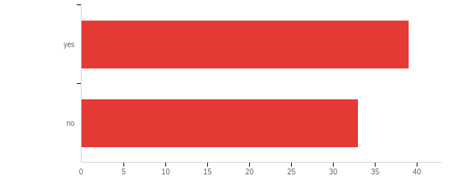

|  |  |  |  |  |  |  |  |
| --- | --- | --- | --- | --- | --- | --- | --- |
| # | Field | Minimum | Maximum | Mean | Std Deviation | Variance | Count |
| 1 | Have you contacted any presenters for more information? | 7.00 | 8.00 | 7.46 | 0.50 | 0.25 | 72 |

|  |  |  |  |
| --- | --- | --- | --- |
| # | Answer | % | Count |
| 7 | yes | 54.17% | 39 |
| 8 | no | 45.83% | 33 |
|  | Total | 100% | 72 |

**Q24 - Did you visit any exhibitors during the conference?**

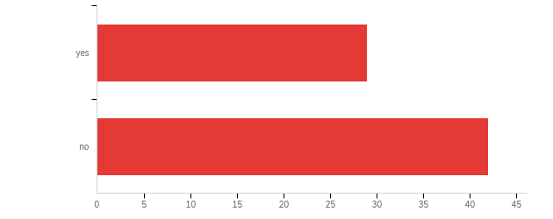

|  |  |  |  |  |  |  |  |
| --- | --- | --- | --- | --- | --- | --- | --- |
| # | Field | Minimum | Maximum | Mean | Std Deviation | Variance | Count |
| 1 | Did you visit any exhibitors during the conference? | 7.00 | 8.00 | 7.59 | 0.49 | 0.24 | 71 |

|  |  |  |  |
| --- | --- | --- | --- |
| # | Answer | % | Count |
| 7 | yes | 40.85% | 29 |
| 8 | no | 59.15% | 42 |
|  | Total | 100% | 71 |

**Q25 - What is your profession? Please select all that apply.**

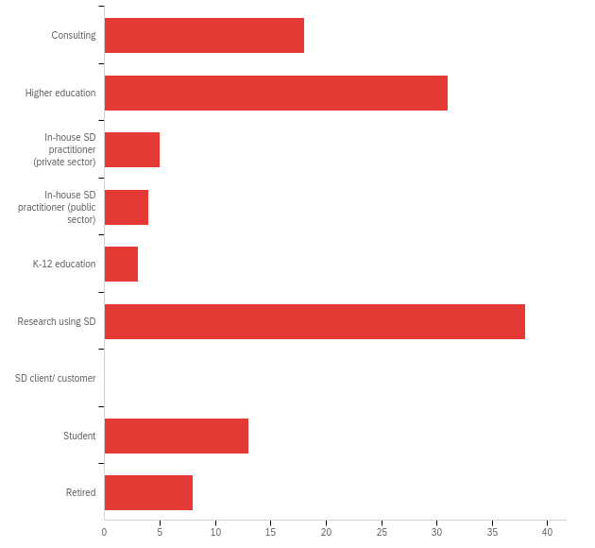

|  |  |  |  |
| --- | --- | --- | --- |
| # | Answer | % | Count |
| 1 | Consulting | 15.00% | 18 |
| 2 | Higher education | 25.83% | 31 |
| 3 | In-house SD practitioner (private sector) | 4.17% | 5 |
| 4 | In-house SD practitioner (public sector) | 3.33% | 4 |
| 5 | K-12 education | 2.50% | 3 |
| 6 | Research using SD | 31.67% | 38 |
| 7 | SD client/ customer | 0.00% | 0 |
| 8 | Student | 10.83% | 13 |
| 9 | Retired | 6.67% | 8 |
|  | Total | 100% | 120 |

**Q25b - Other (please specify)**

|  |
| --- |
| Other (please specify) |
| PhD student |
| Not gainfully employed in an institution, but still active professionally . |
| Software developer |
| pre-college (12+) economics education |

**Q26 - What are your fields of interest? Please check all that apply.**

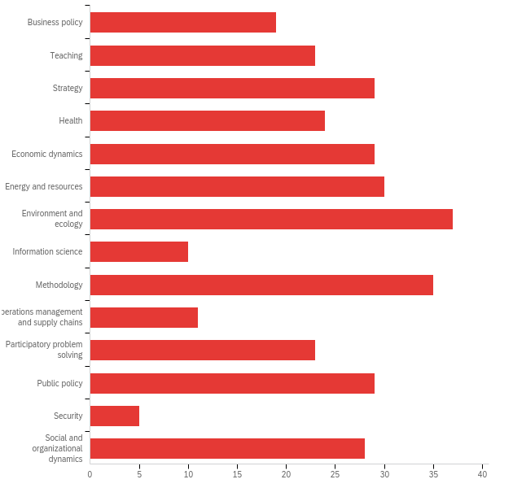

|  |  |  |  |
| --- | --- | --- | --- |
| # | Answer | % | Count |
| 1 | Business policy | 5.72% | 19 |
| 2 | Teaching | 6.93% | 23 |
| 3 | Strategy | 8.73% | 29 |
| 4 | Health | 7.23% | 24 |
| 5 | Economic dynamics | 8.73% | 29 |
| 7 | Energy and resources | 9.04% | 30 |
| 8 | Environment and ecology | 11.14% | 37 |
| 9 | Information science | 3.01% | 10 |
| 10 | Methodology | 10.54% | 35 |
| 11 | Operations management and supply chains | 3.31% | 11 |
| 12 | Participatory problem solving | 6.93% | 23 |
| 13 | Public policy | 8.73% | 29 |
| 14 | Security | 1.51% | 5 |
| 15 | Social and organizational dynamics | 8.43% | 28 |
|  | Total | 100% | 332 |

**Q26b - Other (please specify)**

|  |
| --- |
| Other (please specify) |
| Modeling, Psychology, Human Behavior, History |
| politics |
| Everything |
| Agriculture; natural resource management |
| Human Behaviour and Psychology, Structural Racism |
| Hybrid models |
| Historical dynamics in society |
| construction management |
| Project portfolio management |

**Q27 - What is your geographic region?**

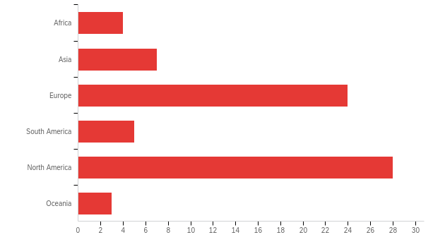

|  |  |  |  |  |  |  |  |
| --- | --- | --- | --- | --- | --- | --- | --- |
| # | Field | Minimum | Maximum | Mean | Std Deviation | Variance | Count |
| 1 | What is your geographic region? | 1.00 | 7.00 | 3.82 | 1.41 | 1.98 | 71 |

|  |  |  |  |
| --- | --- | --- | --- |
| # | Answer | % | Count |
| 1 | Africa | 5.63% | 4 |
| 2 | Asia | 9.86% | 7 |
| 3 | Europe | 33.80% | 24 |
| 4 | South America | 7.04% | 5 |
| 5 | North America | 39.44% | 28 |
| 7 | Oceania | 4.23% | 3 |
|  | Total | 100% | 71 |

**Q27b - Other (please specify)**

|  |
| --- |
| Other (please specify) |
| norway |
| Central América |
| India |

**Q28 - If you have any suggestions for improvements that we can make for future conferences, please list them here.**

|  |
| --- |
| If you have any suggestions for improvements that we can make for future conferences, please list them here. |
| I think participants should be able to import the conference schedule into their personal calendars. |
| parallel-sessions are so interesting, it's irritating that they are parallel... fornunately they can be view post-conference on video recording |
| more opportunity for dialogue in parallel sessions. The WIP approach is good, but tends to be discussing work at an early stage. What we need is that level of discussion about work that has reached the parallel stage, if you see what I mean. 15 minutes talk plus 5 minutes questions is a bit limiting. |
| Did this in previous comments. |
| The conference and society still feel more tilted towards academics and students, with less focus on practitioners who may not have the technical domain knowledge of modeling but who have SME knowledge of the domains that academics are trying to model. Getting more clarity about the big problems to solve in practice (theory in action) is an ongoing challenge. This year's Forrester award on individualized patient care was great - that is the kind of real world problem and solution that we need to keep bringing - more of these. |
| It was a great effort given the challenges. As I said above, a hybrid conference in the future would combine the best of the in-person social aspects for those who can attend with the accessibility of a virtual conference (at a lower fee) for those who cannot attend in person. |
| I really liked the dialogue sessions. That was the only time that we could talk about a very specific topic. Actually, I believe that we can have monthly dialogue sessions for different chapters and SIGS. |
| I think it's better to tolerate hybrid SD work or reject them in advance. |
| Calender integration for sessions would be helpful. I take a while to get warm with groups - so, I would welcome a way to "team up" with others for one or more sessions. |
| Provide more competent, attentive, responsive staff support for the Monday mronnig workshops. |
| Easier to navigate schedule that allows for better promotion of plenaries (or any session really)at public facing level but also for registered attendees to allow them to build a better personalised schedule. More coordination or integration of Echos and dialog sessions (and more Dialog options, perhaps with slightly narrow focus, where needed). And more workshops (not all synchronous!) |
| A lot of people may not like how "busy" or "packed" the conference was because they cannot attend or participate in everything. I guess I understand that concern, but I would encourage the Society to continue "going big" - conferences like this years illustrate just how active so many people are (including newcomers!) using system dynamics, and they need a "home" to share work, successes, insights, and get feedback. Keeping the conference "constrained" to the old format, which may have worked decades ago when the size of the field and number of practitioners was much smaller will eliminate a lot of participation and will discourage newcomers from returning when they cannot engage with others in the field as productively as they do at other conferences. I understand the concerns about the "quality" of system dynamics work being presented, but if we should all realize, no matter how big "stock" of work, the "cream will rise to the top" and we can award and champion those that do, but there should be more and more opportunity to present work at all levels of completion so that newcomers to the field that are excited about SD can gain experience presenting their work, feel "at home" in the society, and get feedback and improve. The costs to the field are too great not to do so, how else will we identify "up and comers" worth investing in from other disciplines, universities, and backgrounds that aren't already "in the family"? |
| As I said already you need to fix the peer review process. This is not intended to be a journal rejecting the majority of submissions. This is intended to give constructive criticism to the authors. If the Program Chairs want help to categorize the papers get the reviewers to submit their recommendations in the section to the Program Chairs directly and not to the authors if they wish to downgrade the paper. |
| no more models to save the world that do not save anything, but models whose purpose are to be implemented. |
| Perhaps the dialogue sessions could occur every day, so we have the opportunity to meet different people more often. |
| Provide more time and information for the models and research presentations |
| I think the trend is positive. |
| Networking improvements (already mentioned). Really like being able to watch videos after so that you can catch up on talks missed. |
| Lower the registration fee for first time attendees |
| Better opportunities for networking, better sponsor availability and visibility. |

**Q29 - Would you recommend this event to others?**

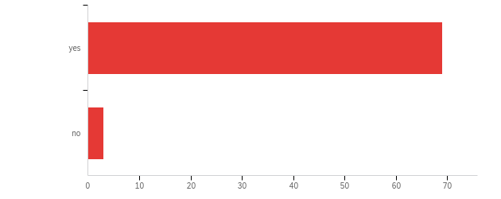

|  |  |  |  |  |  |  |  |
| --- | --- | --- | --- | --- | --- | --- | --- |
| # | Field | Minimum | Maximum | Mean | Std Deviation | Variance | Count |
| 1 | Would you recommend this event to others? | 1.00 | 2.00 | 1.04 | 0.20 | 0.04 | 72 |

|  |  |  |  |
| --- | --- | --- | --- |
| # | Answer | % | Count |
| 1 | yes | 95.83% | 69 |
| 2 | no | 4.17% | 3 |
|  | Total | 100% | 72 |

**Q30 - Do you plan to attend this conference in the future?**

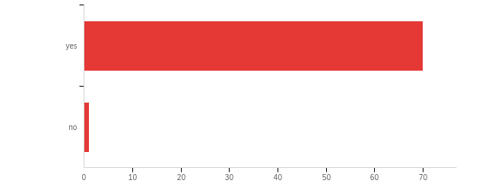

|  |  |  |  |  |  |  |  |
| --- | --- | --- | --- | --- | --- | --- | --- |
| # | Field | Minimum | Maximum | Mean | Std Deviation | Variance | Count |
| 1 | Do you plan to attend this conference in the future? | 1.00 | 2.00 | 1.01 | 0.12 | 0.01 | 71 |

|  |  |  |  |
| --- | --- | --- | --- |
| # | Answer | % | Count |
| 1 | yes | 98.59% | 70 |
| 2 | no | 1.41% | 1 |
|  | Total | 100% | 71 |

**Q31 - The next conference is likely to be a hybrid (virtual and in-person) event. In which way would you prefer to attend?**

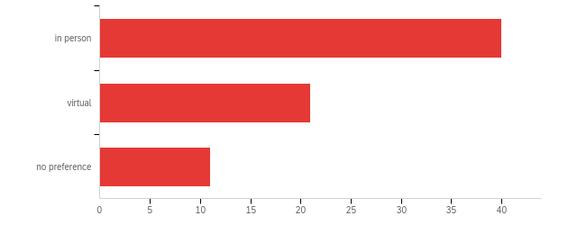

|  |  |  |  |  |  |  |  |
| --- | --- | --- | --- | --- | --- | --- | --- |
| # | Field | Minimum | Maximum | Mean | Std Deviation | Variance | Count |
| 1 | The next conference is likely to be a hybrid (virtual and in-person) event. In which way would you prefer to attend? | 1.00 | 3.00 | 1.60 | 0.74 | 0.55 | 72 |

|  |  |  |  |
| --- | --- | --- | --- |
| # | Answer | % | Count |
| 1 | in person | 55.56% | 40 |
| 2 | virtual | 29.17% | 21 |
| 3 | no preference | 15.28% | 11 |
|  | Total | 100% | 72 |